In [1]:

**import pandas as pd import numpy as np import seaborn as sns**

**import matplotlib.pyplot as plt**

In [2]:

nesarc = pd.read_csv('nesarc.csv', low_memory=**False**) pd.set_option('display.float_format', **lambda** x:'**%f**'%**x**)

# From Prac 1

**Columns/Data used in Prac 1**

In [3]:

nesarc['S2AQ5B'] = pd.to_numeric(nesarc['S2AQ5B'], errors='coerce') *#convert variable t o numeric*

nesarc['S2AQ5D'] = pd.to_numeric(nesarc['S2AQ5D'], errors='coerce') *#convert variable t o numeric*

nesarc['S2AQ5A'] = pd.to_numeric(nesarc['S2AQ5A'], errors='coerce') *#convert variable t o numeric*

nesarc['S2BQ1B1'] = pd.to_numeric(nesarc['S2BQ1B1'], errors='coerce') *#convert variable to numeric*

nesarc['AGE'] = pd.to_numeric(nesarc['AGE'], errors='coerce') *#convert variable to nume ric*

# From Prac 2

**A subset of nesarc data, with the following criteria Age from 26 to 50**

# Beer drinking status - S2AQ5A = Y

In [4]:

sub1=nesarc[(nesarc['AGE']>=26) & (nesarc['AGE']<=50) & (nesarc['S2AQ5A']==1)] sub2=sub1.copy()

# From Prac 2

**SETTING MISSING DATA**

sub2['S2AQ5D']=sub2['S2AQ5D'].replace(99, np.nan)

sub2['S2AQ5B']=sub2['S2AQ5B'].replace(8, np.nan) sub2['S2AQ5B']=sub2['S2AQ5B'].replace(9, np.nan) sub2['S2AQ5B']=sub2['S2AQ5B'].replace(10, np.nan) sub2['S2AQ5B']=sub2['S2AQ5B'].replace(99, np.nan)

sub2['S2BQ1B1']=sub2['S2BQ1B1'].replace(9, np.nan)

# From Prac 2 Recode data

In [6]:

recode2 = {1:30, 2:26, 3:14, 4:8, 5:4, 6:2.5, 7:1}

sub2['BEER_FEQMO']= sub2['S2AQ5B'].map(recode2)

recode3 = {2:0, 1:1}

sub2['S2BQ1B1']= sub2['S2BQ1B1'].map(recode3)

# Plot bar chart for S2BQ1B1

In [7]:

sub2["S2BQ1B1"] = sub2["S2BQ1B1"].astype('category')

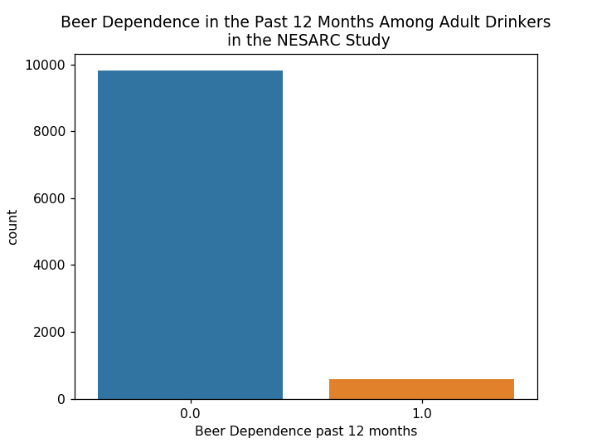In [8]:

%**matplotlib** notebook sns.countplot(x="S2BQ1B1", data=sub2) plt.xlabel('Beer Dependence past 12 months')

plt.title('Beer Dependence in the Past 12 Months Among Adult Drinkers'+ '**\n**' + ' in the NESARC Study')

Out[8]:

Text(0.5,1,'Beer Dependence in the Past 12 Months Among Adult Drinkers\n i n the NESARC Study')

# Visualizing Quantitative Variable - histogram

**From Prac 2**

# Create a secondary variable to estimate the number of beer consumed per month

**NUMBEERMO_EST**

In [9]:

*# A secondary variable multiplying the number of beers comsumed and the approx number o f beers consumed/day*

sub2['NUMBEERMO_EST']=sub2['BEER_FEQMO'] * sub2['S2AQ5D']

# Visualise the number of beers consumed per month (NUMBEERMO_EST) using a histogram

%**matplotlib** notebook

*#Univariate histogram for quantitative variable:* sns.distplot(sub2["NUMBEERMO_EST"].dropna(), kde=**False**); plt.xlabel('Number of Beers per Month')

plt.title('Estimated Number of Beers per Month' + '**\n**' + 'among Adult Beer Drinker in t he NESARC Study')

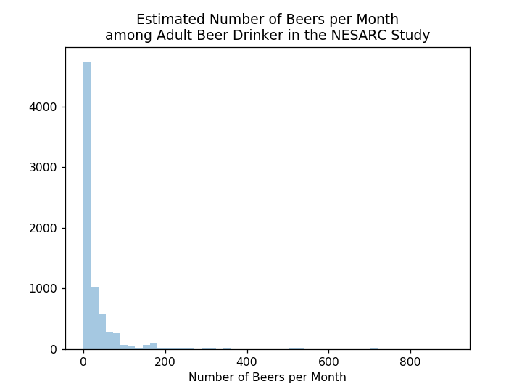

Out[10]:

Text(0.5,1,'Estimated Number of Beers per Month\namong Adult Beer Drinker in the NESARC Study')

# Calculate the spread and centre of NUMBEERMO_EST

**Use describe()**

*# standard deviation and other descriptive statistics for quantitative variables* print('describe number of beers drinking per month')

desc1 = sub2['NUMBEERMO_EST'].describe() print (desc1)

describe number of beers drinking per month

|  |  |
| --- | --- |
| count | 7303.000000 |
| mean | 27.765713 |
| std | 49.201312 |
| min | 1.000000 |
| 25% | 4.000000 |
| 50% | 12.000000 |
| 75% | 28.000000 |
| max | 900.000000 |
| Name: | NUMBEERMO_EST, dtype: float64 |

# Alternative method

**Calculate descriptive statistics of NUMBEERMO_EST**

# Use mean(), std(), min(), max(), median(), mode()

print('mean')

mean1 = sub2['NUMBEERMO_EST'].mean() print (mean1)

print('std')

std1 = sub2['NUMBEERMO_EST'].std() print (std1)

print('min')

min1 = sub2['NUMBEERMO_EST'].min() print (min1)

print ('max')

max1 = sub2['NUMBEERMO_EST'].max() print (max1)

print ('median')

median1 = sub2['NUMBEERMO_EST'].median() print (median1)

print ('mode')

mode1 = sub2['NUMBEERMO_EST'].mode() print (mode1)

mean 27.765712720799673

std 49.201312205771465

min 1.0

max 900.0

median 12.0

mode

0 8.000000

dtype: float64

# Calculate descriptive statistics for categorical data

**S2BQ1B1 - Beer Dependence Use describe()**

In [13]:

print ('describe beer dependence') desc2 = sub2['S2BQ1B1'].describe() print (desc2)

|  |  |
| --- | --- |
| describe | beer dependence |
| count | 10406.000000 |
| unique | 2.000000 |
| top | 0.000000 |
| freq | 9829.000000 |

Name: S2BQ1B1, dtype: float64

# What if categorical data was considered as quantitative data

**S2BQ1B1 - Beer Dependence**

# Convert S2BQ1B1 to quantitative data and Calculate descriptive statistics

**Use describe()**

In [14]:

sub2['S2BQ1B1'] = pd.to_numeric(sub2['S2BQ1B1']) *# convert a numerical variable to quan titatie*

In [15]:

print ('describe beer dependence') desc3 = sub2['S2BQ1B1'].describe()

print (desc3) *#descriptor don't have sense*

describe beer dependence

|  |  |
| --- | --- |
| count | 10406.000000 |
| mean | 0.055449 |
| std | 0.228865 |
| min | 0.000000 |
| 25% | 0.000000 |
| 50% | 0.000000 |
| 75% | 0.000000 |
| max | 1.000000 |
| Name: | S2BQ1B1, dtype: float64 |

# Visualising 2 variable

**Categorical -> Quantitative - Bar chart**

# Create a secondary variable

**CARTONPERMONTH - number of beer carton consumed per month**

# assume that there is 24 beer cans in a carton

In [16]:

sub2['CARTONPERMONTH']=sub2['NUMBEERMO_EST'] / 24

In [17]:

c2= sub2.groupby('CARTONPERMONTH').size() print (c2)

CARTONPERMONTH

|  |  |
| --- | --- |
| 0.041667 | 477 |
| 0.083333 | 407 |
| 0.104167 | 414 |
| 0.125000 | 172 |
| 0.166667 | 429 |
| 0.208333 | 623 |
| 0.250000 | 36 |
| 0.291667 | 5 |
| 0.312500 | 267 |
| 0.333333 | 635 |
| 0.416667 | 119 |
| 0.500000 | 296 |
| 0.520833 | 48 |
| 0.583333 | 160 |
| 0.625000 | 87 |
| 0.666667 | 561 |
| 0.729167 | 5 |
| 0.750000 | 1 |
| 0.833333 | 81 |
| 0.937500 | 3 |
| 1.000000 | 410 |
| 1.041667 | 6 |
| 1.083333 | 51 |
| 1.145833 | 1 |
| 1.166667 | 242 |
| 1.250000 | 62 |
| 1.333333 | 168 |
| 1.458333 | 1 |
| 1.500000 | 3 |
| 1.562500 | 2 |
|  | ... |
| 4.083333 | 9 |
| 4.333333 | 37 |
| 4.666667 | 21 |
| 5.000000 | 39 |
| 5.416667 | 13 |
| 5.833333 | 5 |
| 6.000000 | 2 |
| 6.250000 | 18 |
| 6.500000 | 54 |
| 7.000000 | 27 |
| 7.500000 | 77 |
| 7.583333 | 6 |
| 8.000000 | 3 |
| 8.666667 | 10 |
| 8.750000 | 5 |
| 9.750000 | 2 |
| 10.000000 | 13 |
| 10.500000 | 5 |
| 10.833333 | 3 |
| 11.250000 | 4 |
| 12.500000 | 6 |
| 13.000000 | 14 |
| 15.000000 | 25 |
| 19.500000 | 1 |
| 21.250000 | 1 |
| 21.666667 | 1 |
| 22.500000 | 2 |
| 26.000000 | 1 |
| 30.000000 | 2 |

37.500000 1

Length: 75, dtype: int64

# Group CARTONPERMONTH into 7 groups 1 - 5 cartons

**6 - 10 cartons**

# 11 - 15 cartons

**16 - 20 cartons**

# 21 - 25 cartons

**26 - 30 cartons 31 - max cartons**

In [23]:

sub2['CARTONCATEGORY'] = pd.cut(sub2.CARTONPERMONTH, [0, 5, 10, 15, 20, 25, 30, 38])

In [24]:

*# change format from numeric to categorical* sub2['CARTONCATEGORY'] = sub2['CARTONCATEGORY'].astype('category')

# Print describe of CARTONCATEGORY

In [25]:

print('describe CARTONCATEGORY')

desc3 = sub2['CARTONCATEGORY'].describe() print (desc3)

describe CARTONCATEGORY count 7303

unique 7

top (0, 5]

freq 7002

Name: CARTONCATEGORY, dtype: object

# Print carton category counts

In [26]:

print('carton category counts')

c7 = sub2['CARTONCATEGORY'].value_counts(sort=**False**, dropna=**True**) print(c7)

carton category counts (0, 5] 7002

(5, 10] 235

|  |  |  |
| --- | --- | --- |
| (10, | 15] | 57 |
| (15, | 20] | 1 |
| (20, | 25] | 4 |
| (25, | 30] | 3 |
| (30, | 38] | 1 |

Name: CARTONCATEGORY, dtype: int64

# Chart of bar chart showing the relationship between carton of beer consumed per month (CARTONCATEGORY) and Beer Dependent (S2BQ1B1)

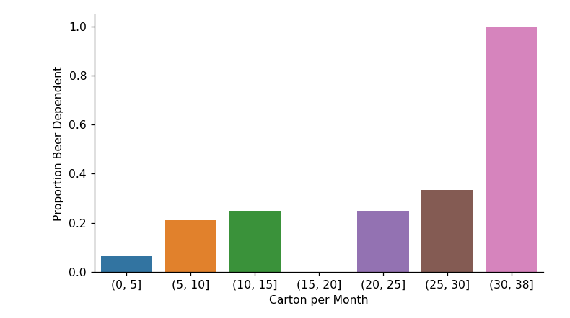In [27]:

*# bivariate bar graph C->Q*

sns.factorplot(x="CARTONCATEGORY", y="S2BQ1B1", data=sub2, kind="bar", ci=**None**) plt.xlabel('Carton per Month')

plt.ylabel('Proportion Beer Dependent')

Out[27]:

Text(9.44444,0.5,'Proportion Beer Dependent')

# Visualising 2 variable

**Categorical -> Categorical - Bar chart**

# Rename race from 1-5 to "White", "Black", "NatAm", "Asian", "Hispanic"

In [28]:

*# you can rename categorical variable values for graphing if original values are not in formative*

*# first change the variable format to categorical if you haven’t already done so* sub2['ETHRACE2A'] = sub2['ETHRACE2A'].astype('category')

*# second create a new variable (PACKCAT) that has the new variable value labels* sub2['ETHRACE2A']=sub2['ETHRACE2A'].cat.rename_categories(["White", "Black", "NatAm", "Asian", "Hispanic"])

# Function to get 'CARTON_ADAY)

In [29]:

**def** CARTON_ADAY (row):

**if** row['BEER_FEQMO'] >= 30 :

**return** 1

**elif** row['BEER_FEQMO'] < 30 : **return** 0

sub2['CARTON_ADAY'] = sub2.apply (**lambda** row: CARTON_ADAY (row),axis=1) c4= sub2.groupby('CARTON_ADAY').size()

print(c4)

|  |  |
| --- | --- |
| CARTON_ADAY |  |
| 0.000000 | 6897 |
| 1.000000 | 417 |
| dtype: int64 |  |

# Bar Graph showing the relationship between race (ETHRACE2A) and

**CARTON_ADAY**

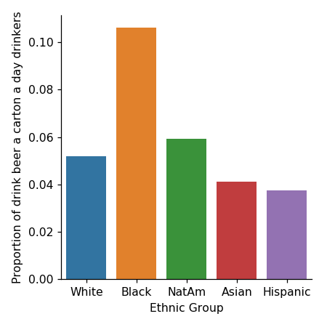In [30]:

*# bivariate bar graph C->C*

sns.factorplot(x='ETHRACE2A', y='CARTON_ADAY', data=sub2, kind="bar", ci=**None**) plt.xlabel('Ethnic Group')

plt.ylabel('Proportion of drink beer a carton a day drinkers')

Out[30]:

Text(0.694444,0.5,'Proportion of drink beer a carton a day drinkers')

# Visualising 2 variable

**Categorical -> Quantitative - box plot**

# convert age to category data type

**convert income (S1Q10A) to numeric data type**

In [31]:

sub2['AGE'] = sub2['AGE'].astype('category') sub2['S1Q10A'] = pd.to_numeric(sub2['S1Q10A'])

# Box plot to show the relationship between age and income (S1Q10A) among adults aged 26 - 50 years old.

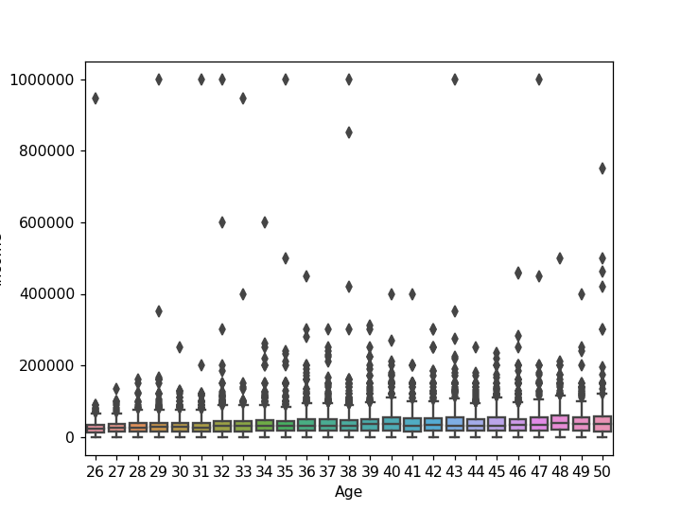In [32]:

%**matplotlib** notebook

sns.boxplot(x='AGE', y='S1Q10A', data=sub2) plt.xlabel('Age')

plt.ylabel('Income')

Out[32]:

Text(0,0.5,'Income')

# Visualising 2 variable

**Quantitative -> Quantitative - scatter plot Read in gapminder.csv**

pd.set_option('display.float_format', **lambda** x:'**%.2f**'%**x**)

gapminder = pd.read_csv('gapminder.csv', low_memory=**False**) gapminder.head()

Out[33]:

|  |  |  |  |  |  |
| --- | --- | --- | --- | --- | --- |
|  | **country** | **incomeperperson** | **alcconsumption** | **armedforcesrate** | **breastcancerper** |
| **0** | Afghanistan |  | .03 | .5696534 | 26.8 |
| **1** | Albania | 1914.99655094922 | 7.29 | 1.0247361 | 57.4 |
| **2** | Algeria | 2231.99333515006 | .69 | 2.306817 | 23.5 |
| **3** | Andorra | 21943.3398976022 | 10.17 |  |  |
| **4** | Angola | 1381.00426770244 | 5.57 | 1.4613288 | 23.1 |

# convert 'oilperperson' and 'relectricperperson' to numeric

In [34]:

gapminder['oilperperson'] = pd.to_numeric(gapminder['oilperperson'],errors='coerce') gapminder['relectricperperson'] = pd.to_numeric(gapminder['relectricperperson'],errors= 'coerce')

# drop NAN data

In [35]:

gapminder_clean=gapminder.dropna()

# Scatter plot to show the relationship between Electrcity Use Per Person (relectricperperson) and Oil Use Per Person (oilperperson)

%**matplotlib** notebook plt.figure()

scat1 = sns.regplot(x="relectricperperson", y="oilperperson", fit_reg=**False**, data=gapmi nder_clean)

plt.xlabel('Electrcity Use Per Person') plt.ylabel('Oil Use Per Person')

plt.title('Scatterplot for the Association Between Electrcity Use Per Person' + '**\n**' + 'and Oil Use Per Person')

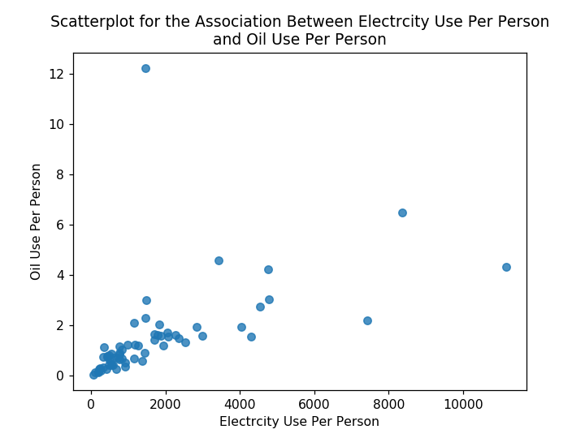

Out[36]:

Text(0.5,1,'Scatterplot for the Association Between Electrcity Use Per Per son\nand Oil Use Per Person')